ML Algorithms

Gradient Boosting Regressor:

How it works:
Let's say we are trying to predict a person's Age.
- Actual Age: 88
- Learning Rate (eta): 0.1 (We'll explain this later).

Step 1: The Baseline Prediction
GBM always starts with a leaf node that predicts the Average of the entire dataset.
- Prediction 0: 70 (Average age).
- Residual (Error): 88 - 70 = 18.
- Note: The model missed by 18 years
Step 2: Build Tree 1 (The "Error Specialist")
We build a Decision Tree. But here is the magic: We do NOT give it the label "88". We tell it: "Your job is to predict the number 18."
- Tree 1 looks at the features (Health, Income, etc.) and predicts: 16.
- Update: We don't just add 16. We multiply by the Learning Rate (0.1).
  - New Prediction = 70 + (0.1 \times 16) = 71.6.
- New Residual: $88 - 71.6 = 16.4$.
why did I multiply by 0.1? Why not just add the full 16?
- You will likely Overshoot the target immediately (Overfitting). The model becomes erratic.

Step 3: Build Tree 2
We build another tree. We tell it: "Your job is to predict the number 16.4."
- Tree 2 looks at features and predicts: 15.
- Update:
  - New Prediction = $71.6 + (0.1 \times 15) = 73.1$.
- New Residual: $88 - 73.1 = 14.9$.
We repeat these 100 or 1,000 times. We slowly "nudge" the prediction closer and closer to the truth.

Mathematical Intuition:

The boosting Uses Additive Modelling:
In machine learning, we often try to find a function F(x) that predicts y.
- Traditional Approach: Try to find one complex, perfect formula.
Y - approx. - f(x)
- Additive Modelling Approach: Assume that the "perfect formula" is actually just the sum of many small, stupid formulas.

So, first Step in the algo for gradient boosting is mean as we know it comes out from (mathematically)
Where we need to find the value of gamma(y) in which the loss function is minimum
The loss function use is
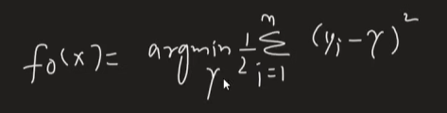
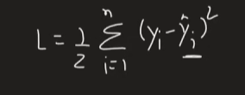
I come out to be:

So will find the differentiation with respect to gamma
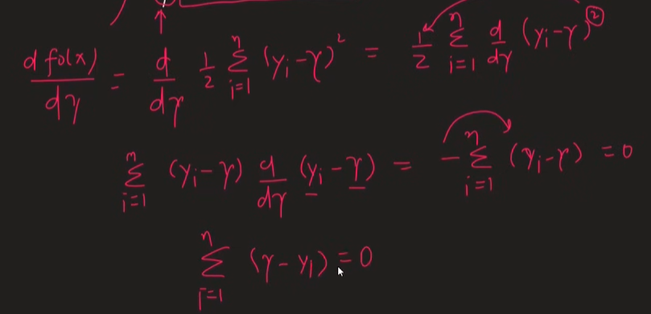

For example, we take this dataset then:
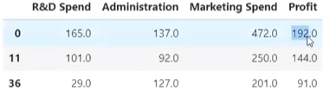
Then gamma comes out to be after putting these values in formula

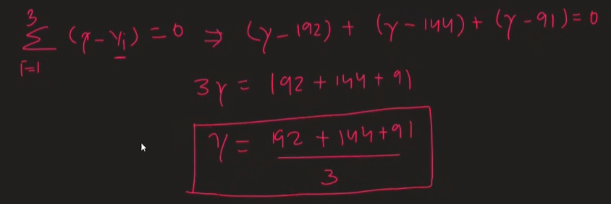

From this we find out f₀(x) as it is our first function and is mean

Now step two in which we use decision tree to predict the residual of first one goes like (mathematically)
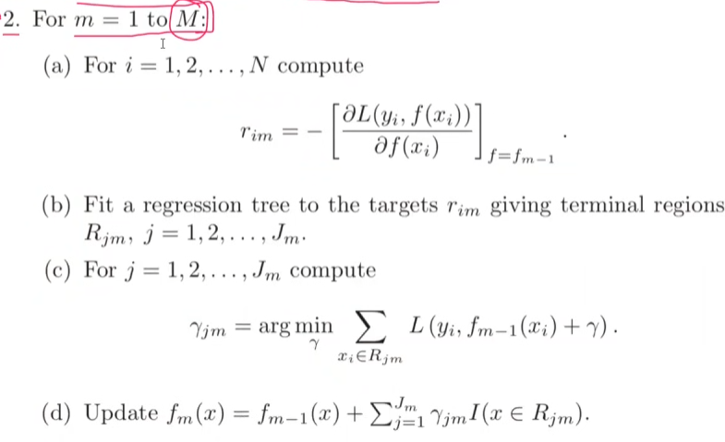

So, in this i represent row number and m represent decision tree we are on or the function
r is residual which we calculate for every row
as we have three rows will find r₁₁, r_{21,} r₃₁ for Decision tree 1

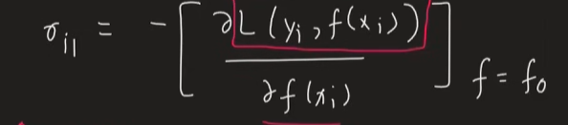
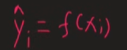
As,

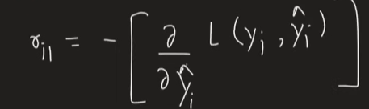
As we know our loss function then
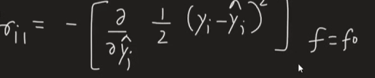
After differentiation we get,
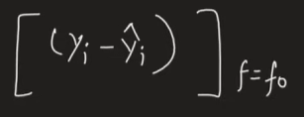

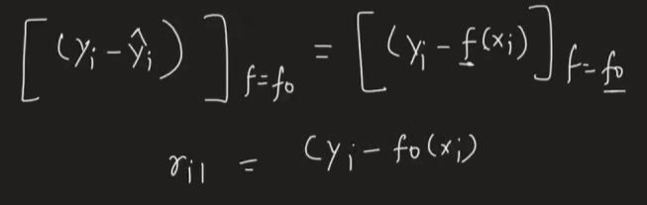
According to our example dataset we get,
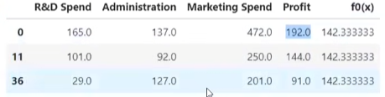
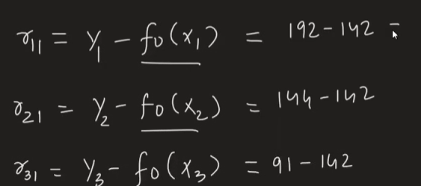
Now next sub step in step two is to fit regression tree take input as,
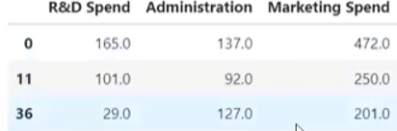
And output as,
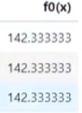

Now we get different terminal regions as in our dataset we get two of them
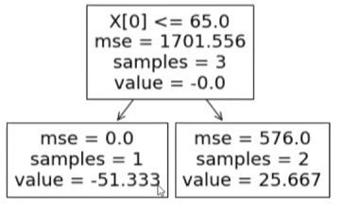
Now next sub step of the algorithm
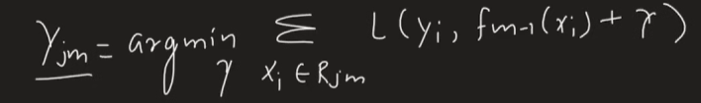
Where j is the no of decision regions we need to find 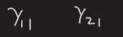
As our r₁₁ has one sample so
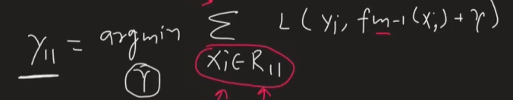

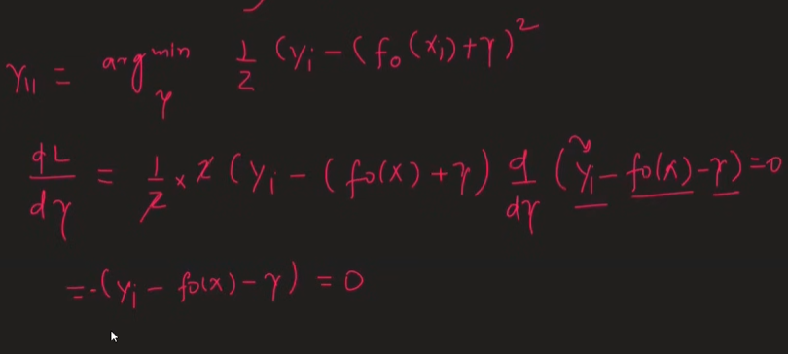
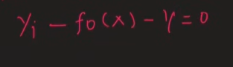
As for example we get 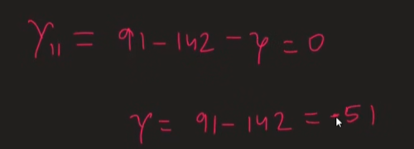
Finding gamma₂₁ :
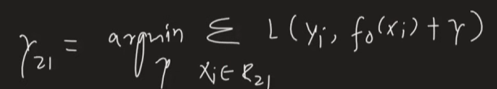

In this we have two samples
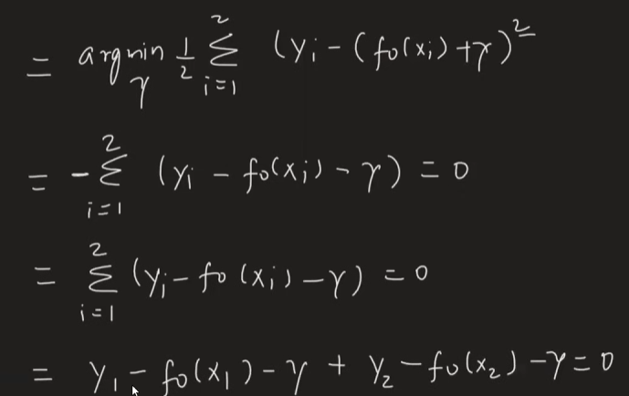

Our dataset comes out to be,
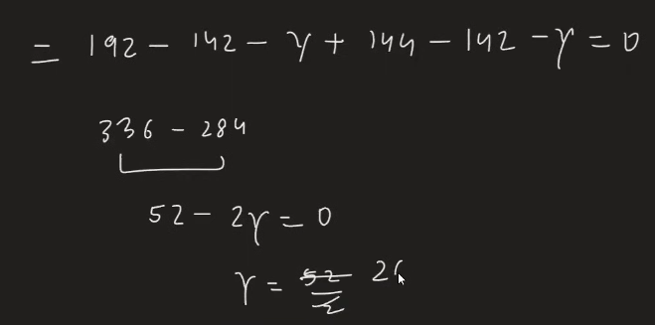
Next sub step is to update the values from concurrent decision tree output
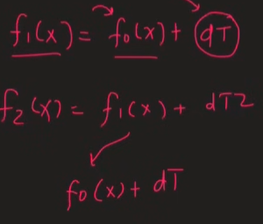
Last step is to find the output,
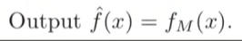

Gradient boosting Classification:
- As we know we use multiple weak learners with high bias and do additive modelling and make it low bias
- The whole geometrically and mathematical intuition is same as regression but only loss function is changed to log loss

Note that gradient-boosted trees are always regression trees, even when they are used for classification problems
How does it work:
Will take example with toy dataset
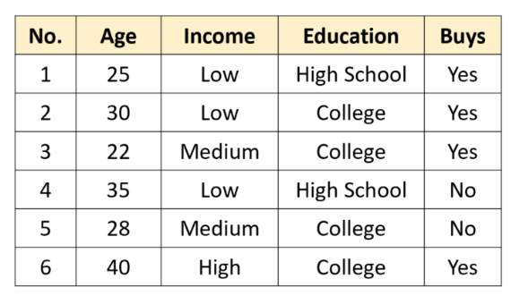
The goal is to predict whether a customer will buy a given product based on three attributes: the customer’s age, level of income (Low, Medium or High) and level of education (High School or College).
maximum depth of 2, and a learning rate of ν = 0.5
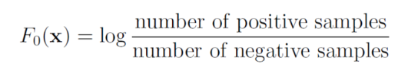

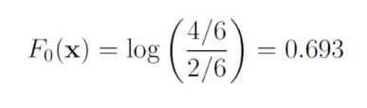
Next, we calculate the pseudo-residuals. For the log loss function, these are simply the actual labels minus the predicted labels:
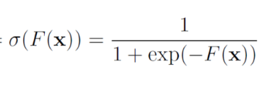
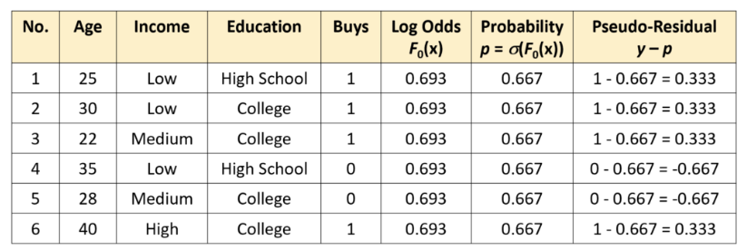

We now fit a regression tree to the pseudo-residuals.
- Features (Inputs): Age, Income, Education.
- Target (Label): The Pseudo-Residual column (0.333, -0.667, etc.). NOT the "Buys" column.

Next, we Calculate the Output Value for Each Leaf
This is the tricky part specific to Classification.
- Standard Regression Tree: Would just take the average of the residuals in the leaf.
- GBM Classification: We cannot just add a "probability error" to a "log-odds score." We need to transform the leaf value so it makes sense in "log-odds land."
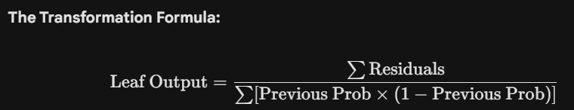
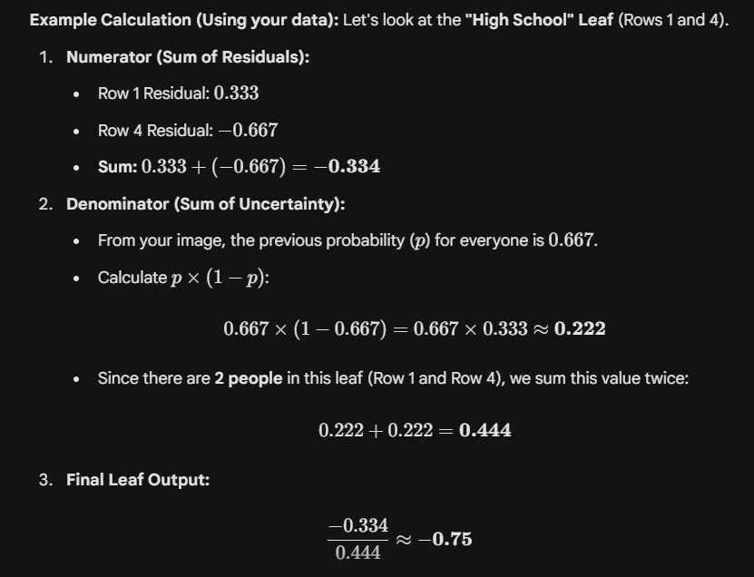
Update the Predictions
Now we update the Log-Odds for the people in the "High School" group using the Learning Rate (which is v = 0.5$ in your image).


